Random Forests Bagging (jupyter)

[1]these links to explain theory of Random forests :

<https://medium.com/@curryrowan/the-complete-guide-to-random-forests-part-1-427c9cba8336>

and

<https://medium.com/@curryrowan/the-complete-guide-to-random-forests-part-2-934eabf35534>

# [2]this link to explain Bootstrapping, Bagging,& Boosting :

# <https://medium.com/@curryrowan/the-three-bs-bootstrapping-bagging-boosting-43df4b372a6a>

# [3] Download Code and DataSet from kaggle:

# <https://www.kaggle.com/code/rowancurry/random-forests-90-5-accuracy>

# 

[4] DATASET: The Dataset used is the Rain in Australia dataset on Kaggle.

[5] Add a new cell and write this line of code [!pip install imblearn] to install imblearn library.

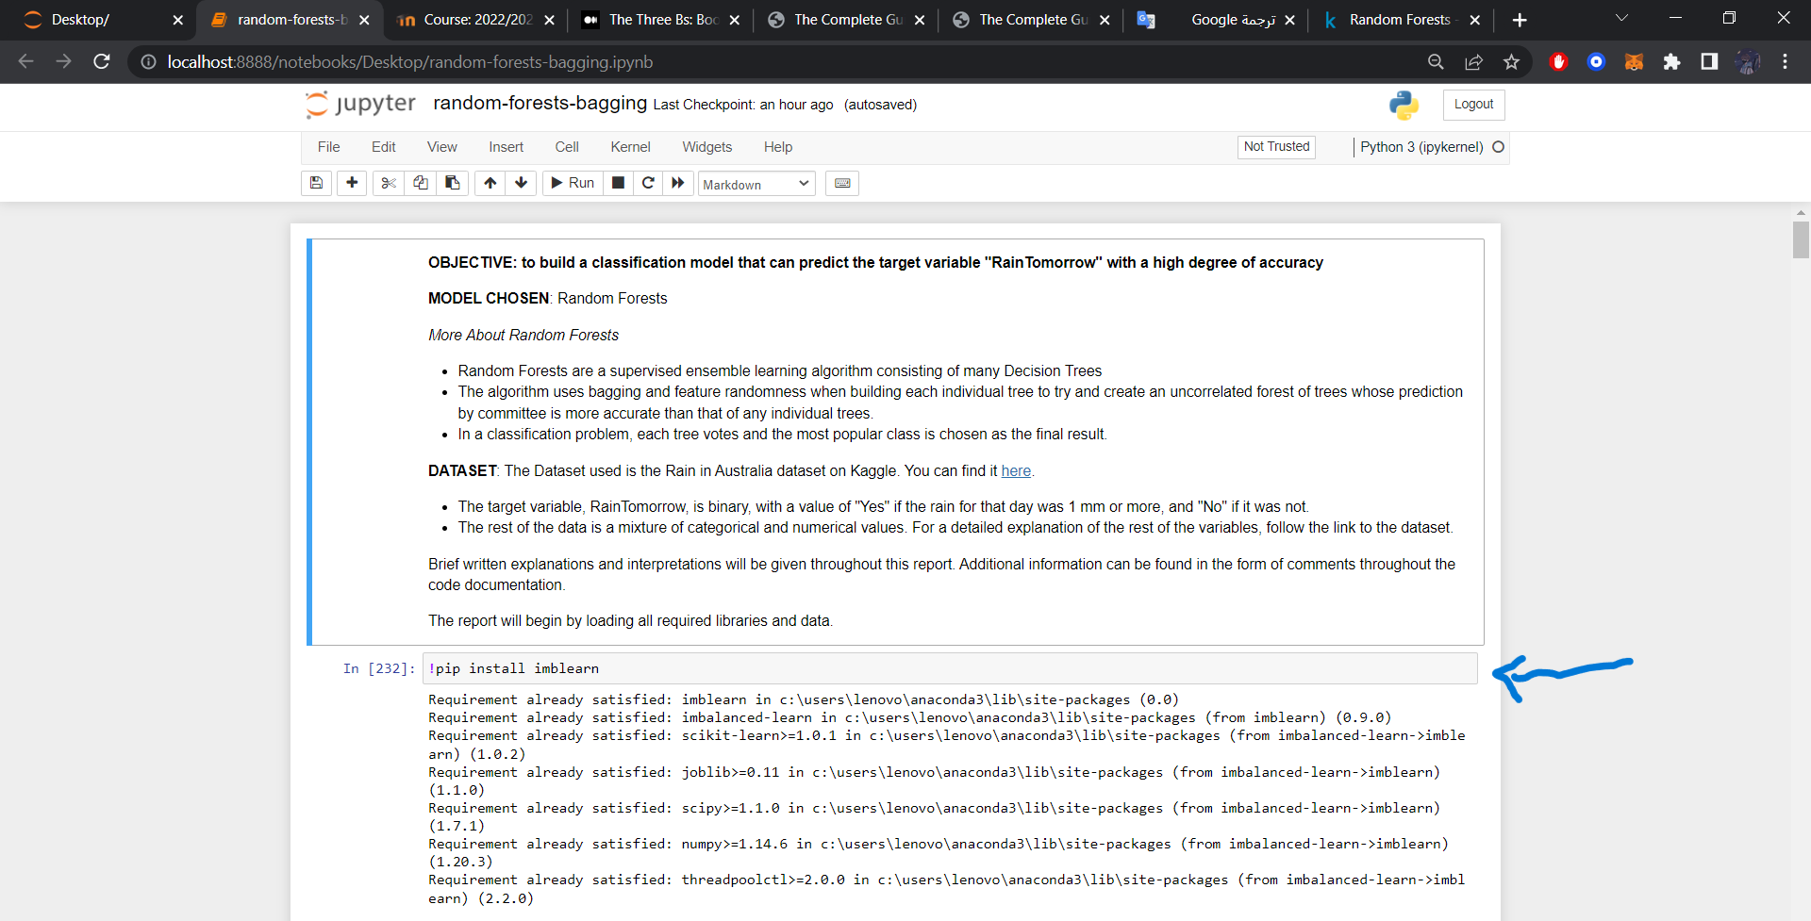

[6] Change this line of code [df = pd.read_csv("../input/weather-dataset-rattle-package/weatherAUS.csv")] to [df = pd.read_csv("weatherAUS.csv")].

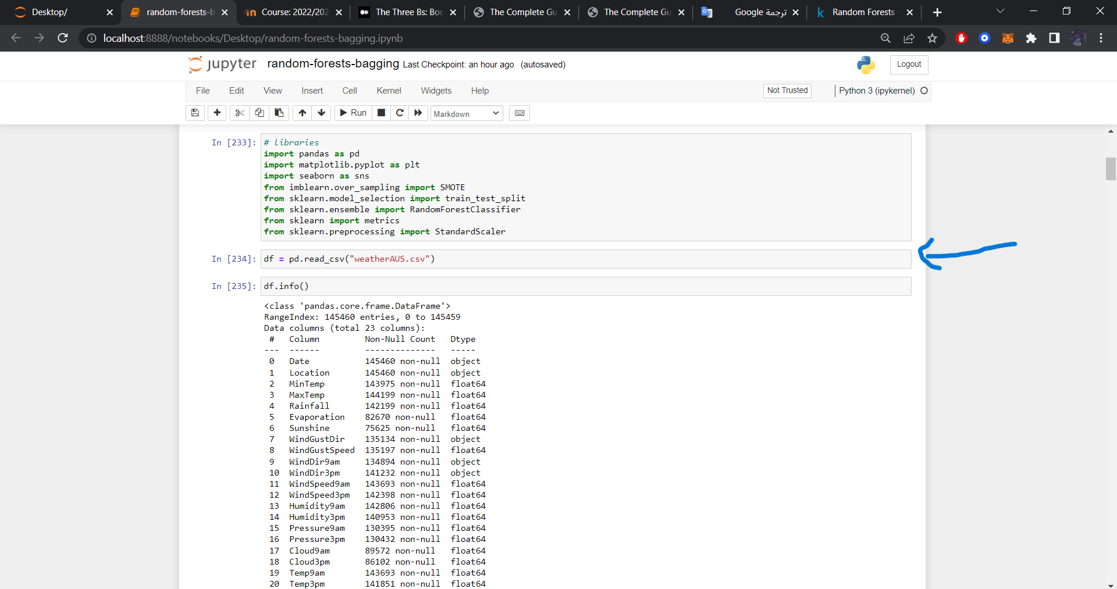

[7]Run the code!

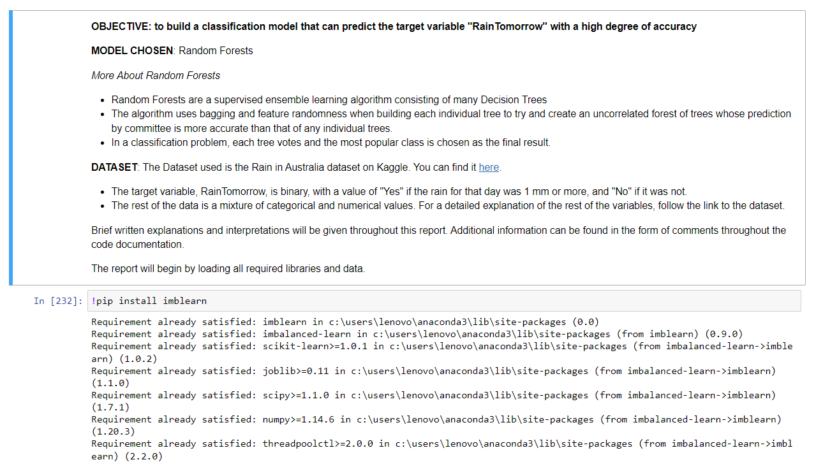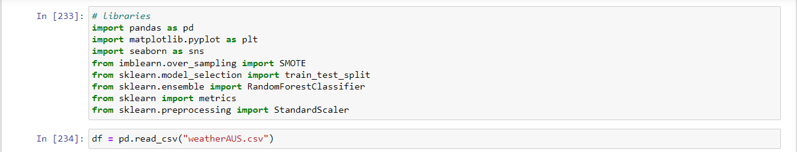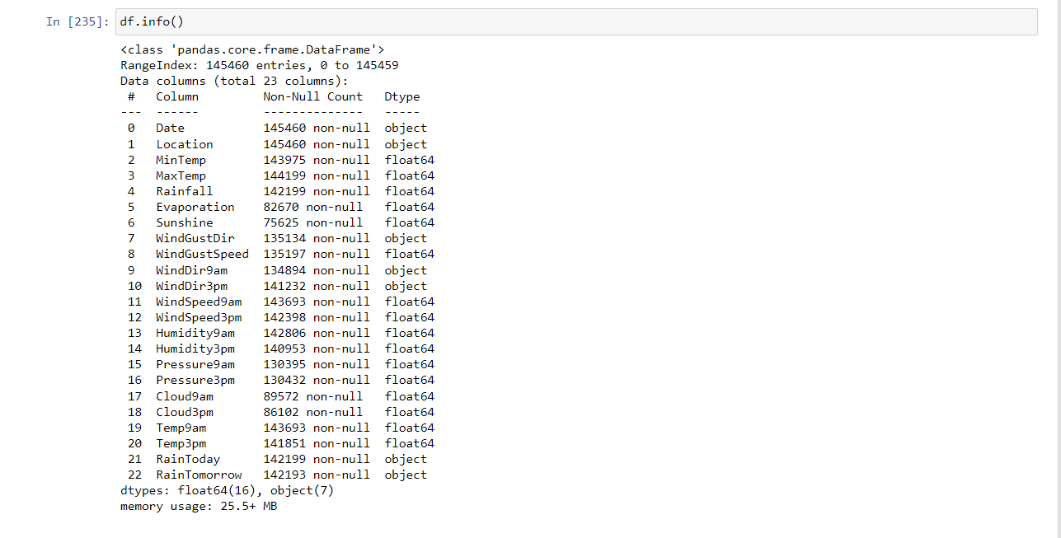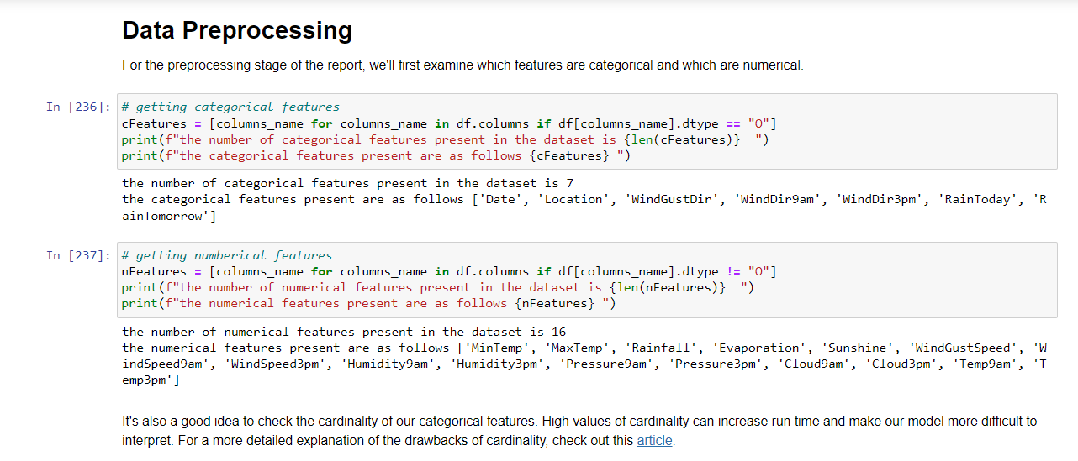

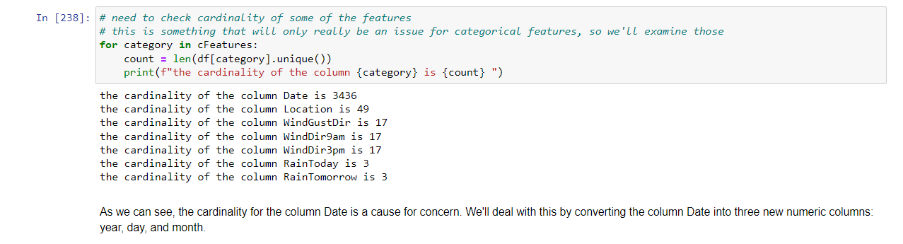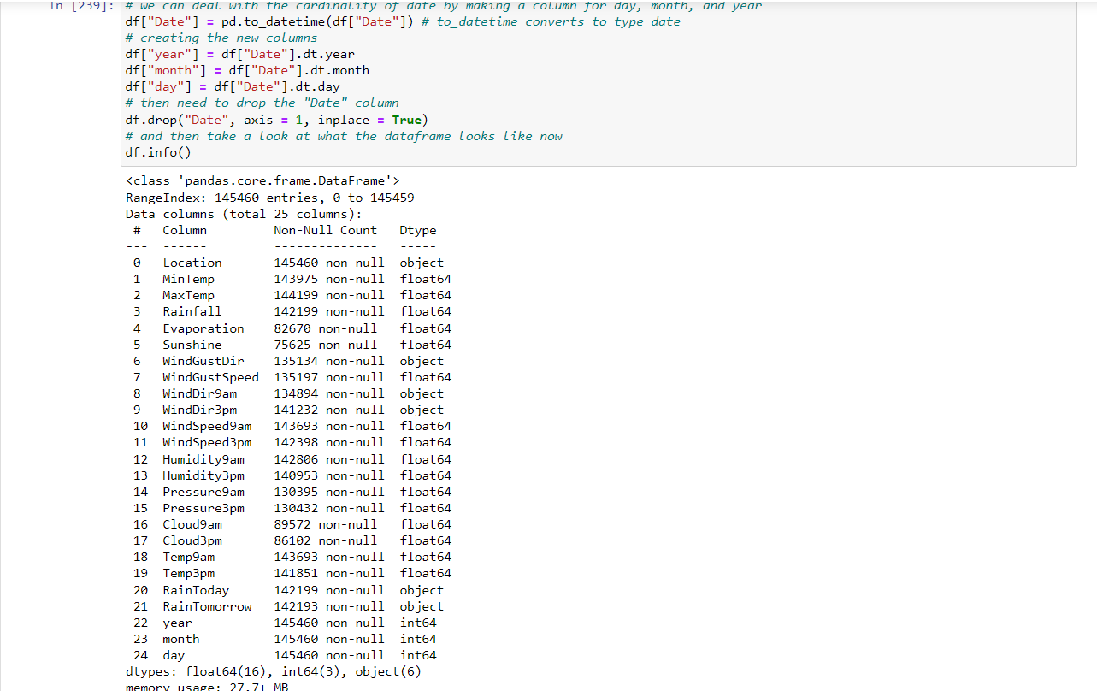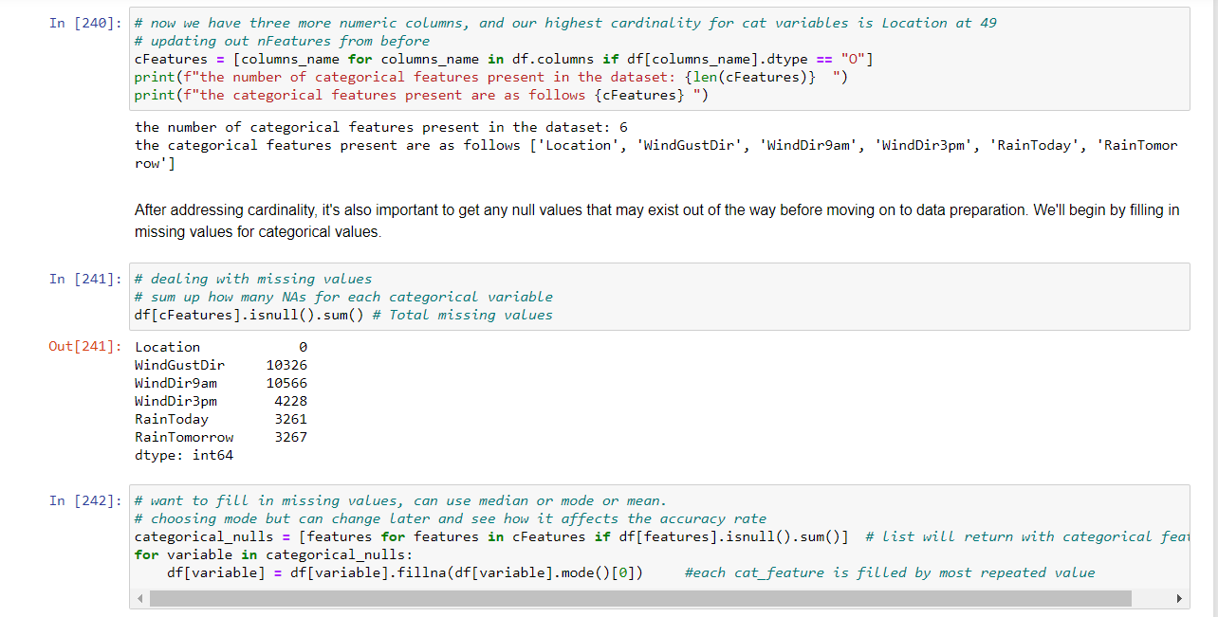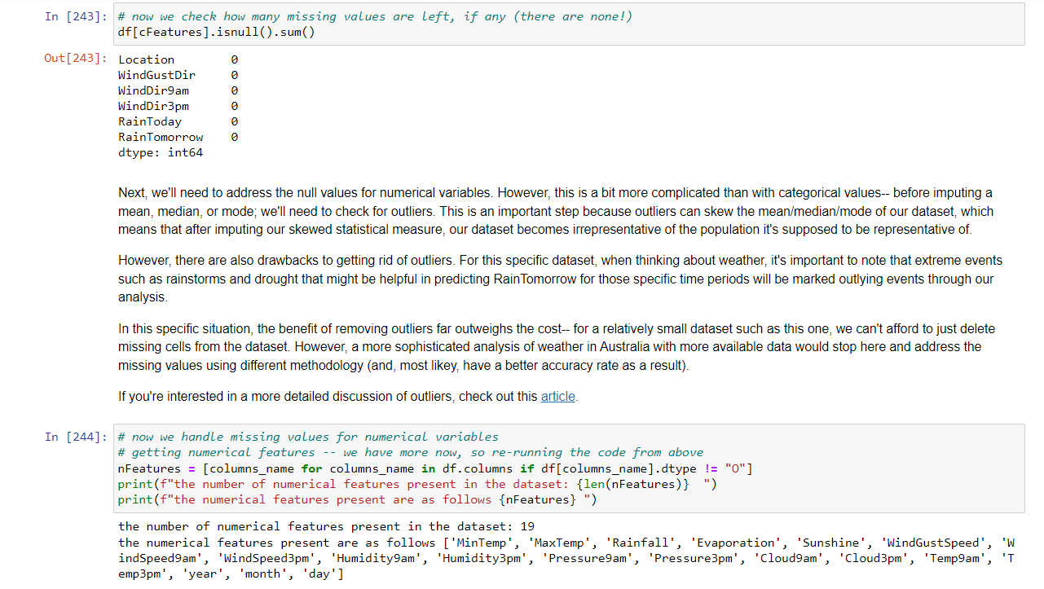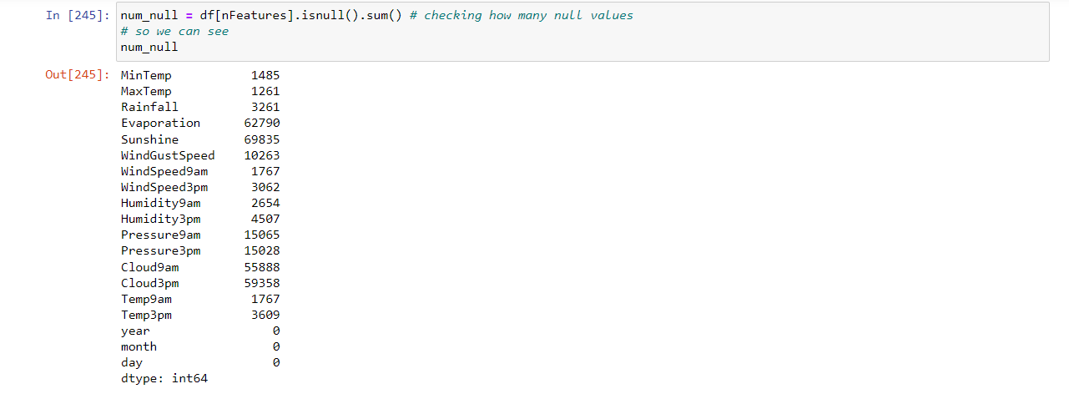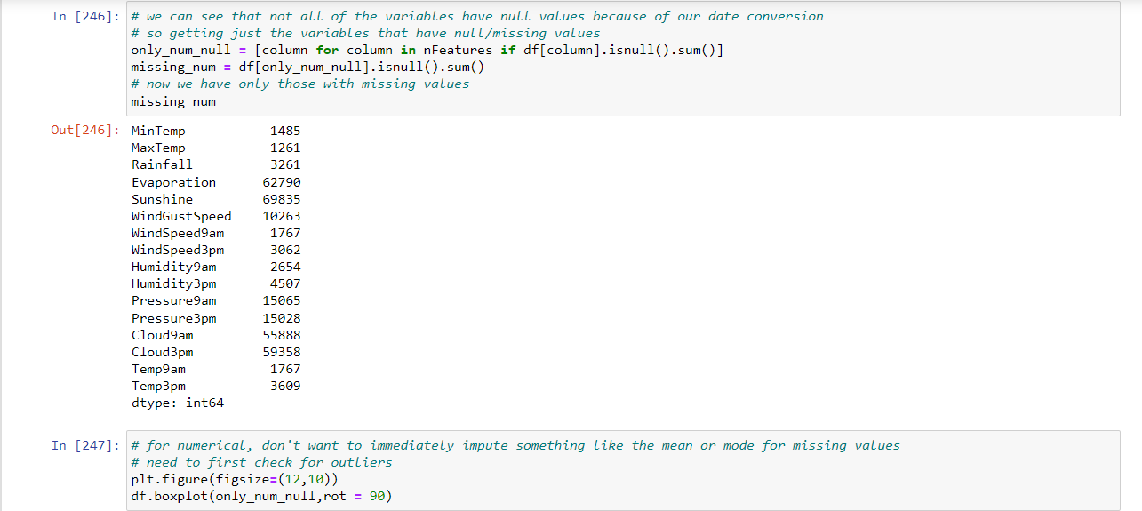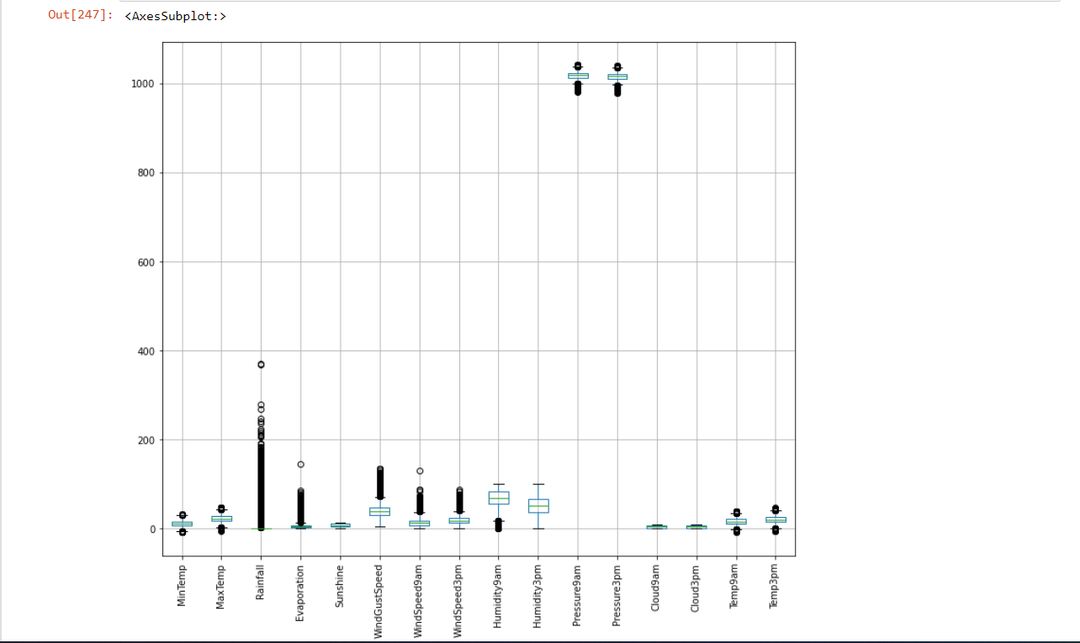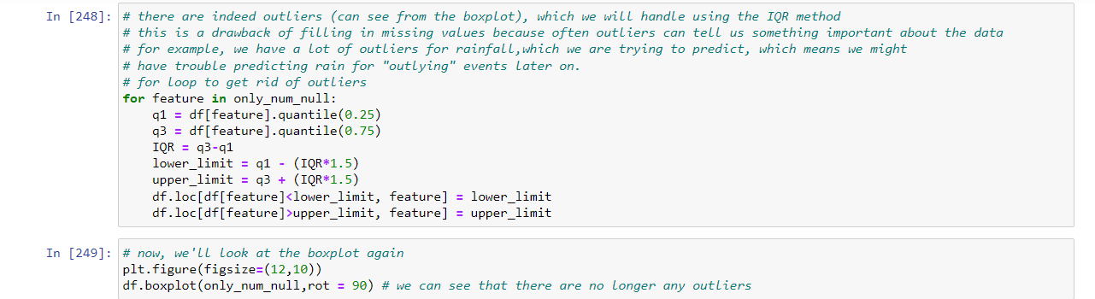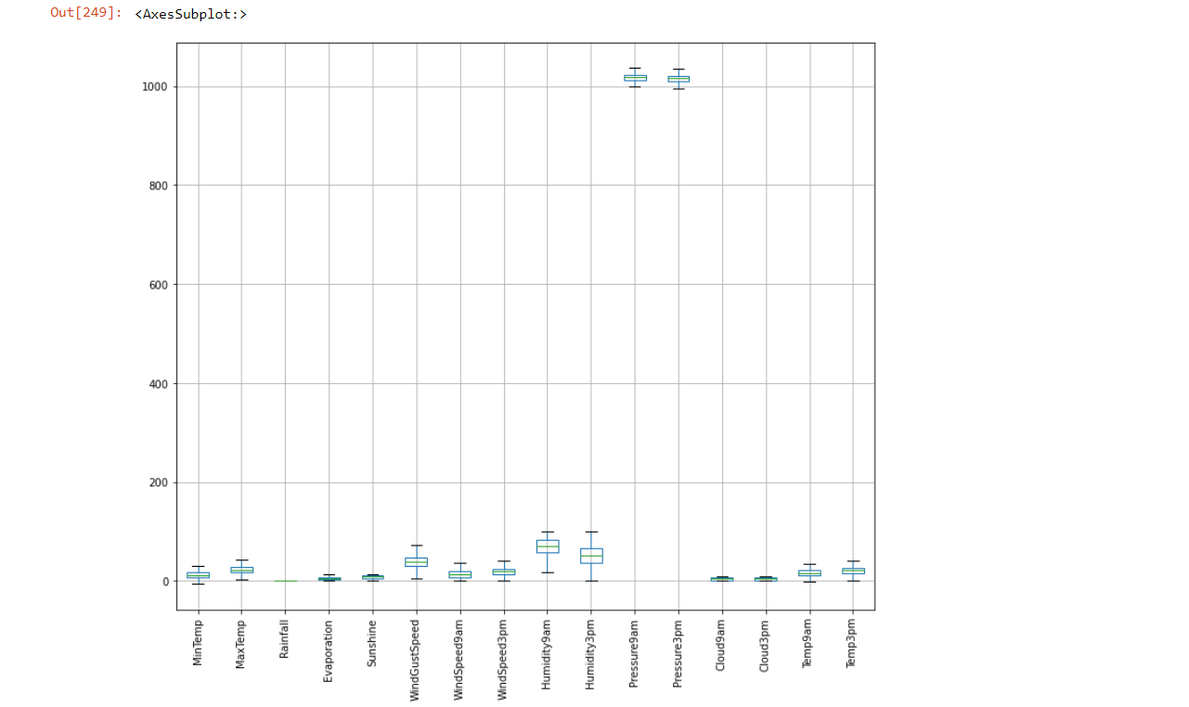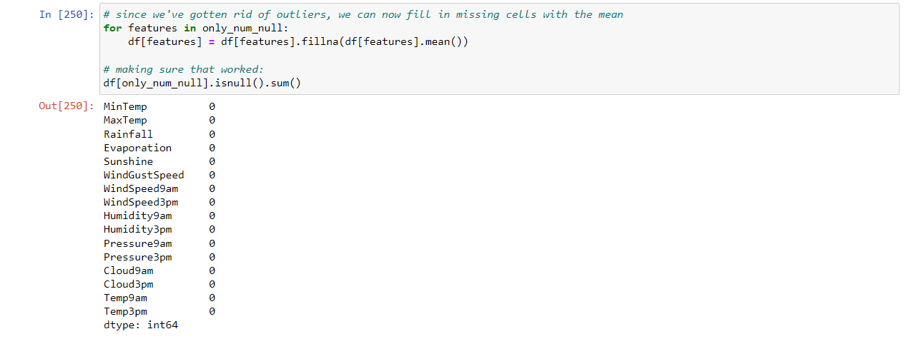

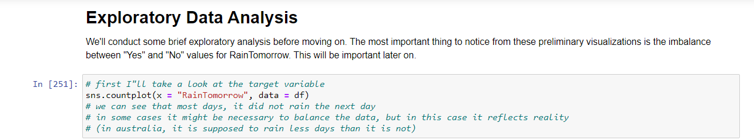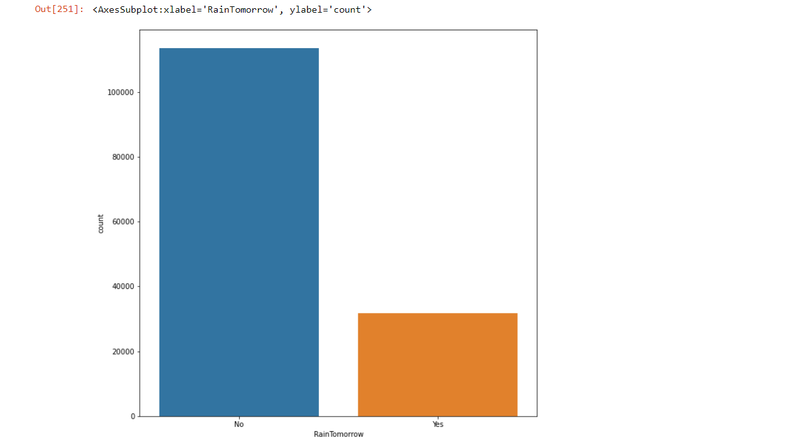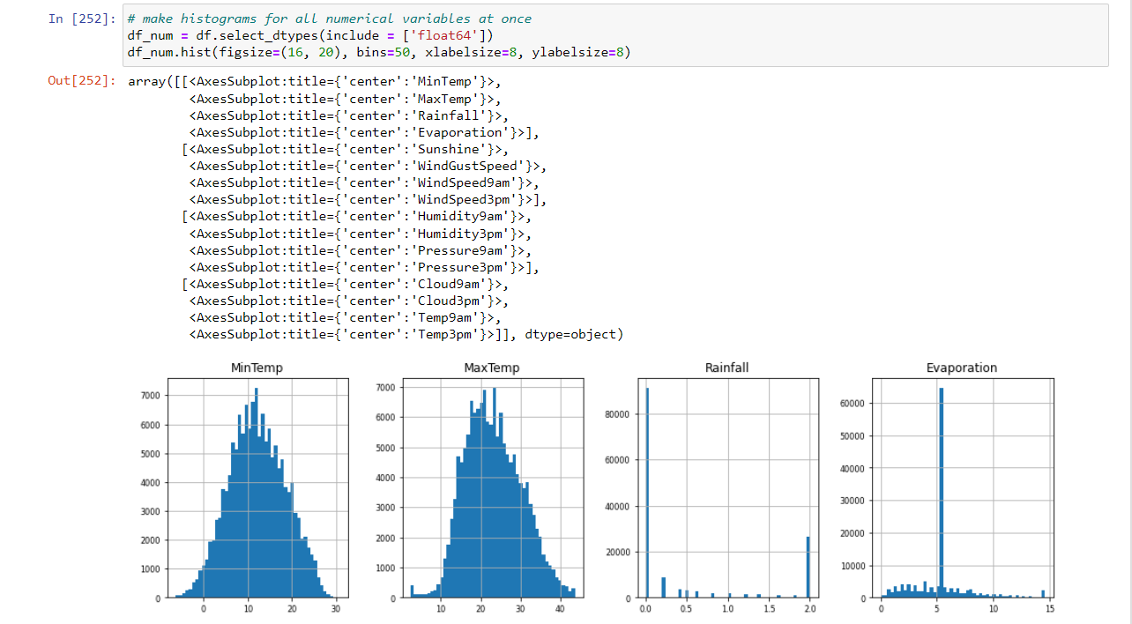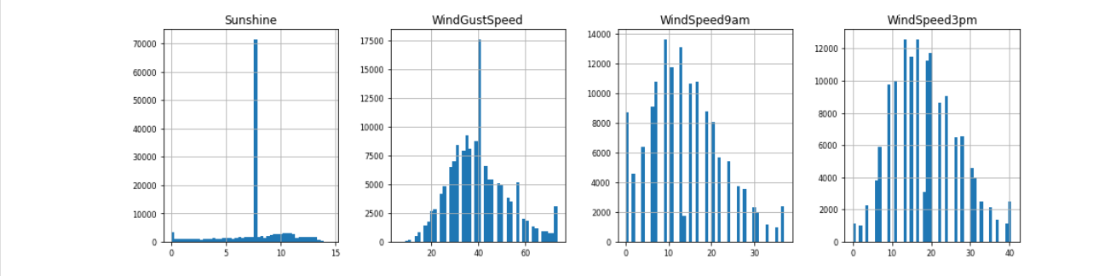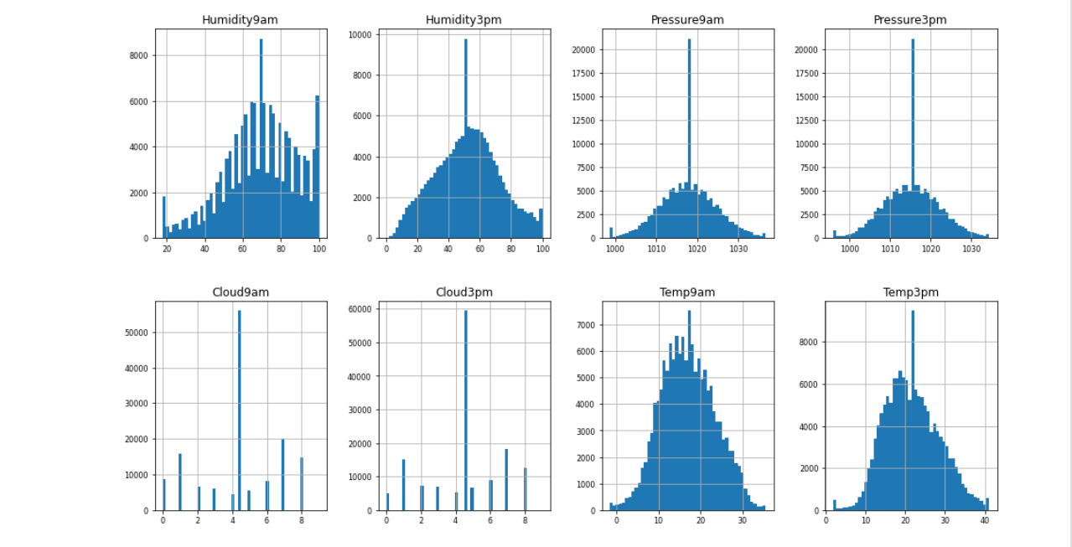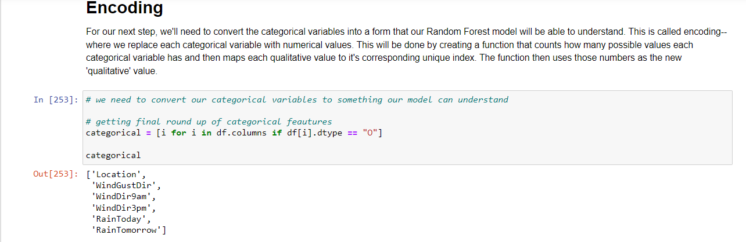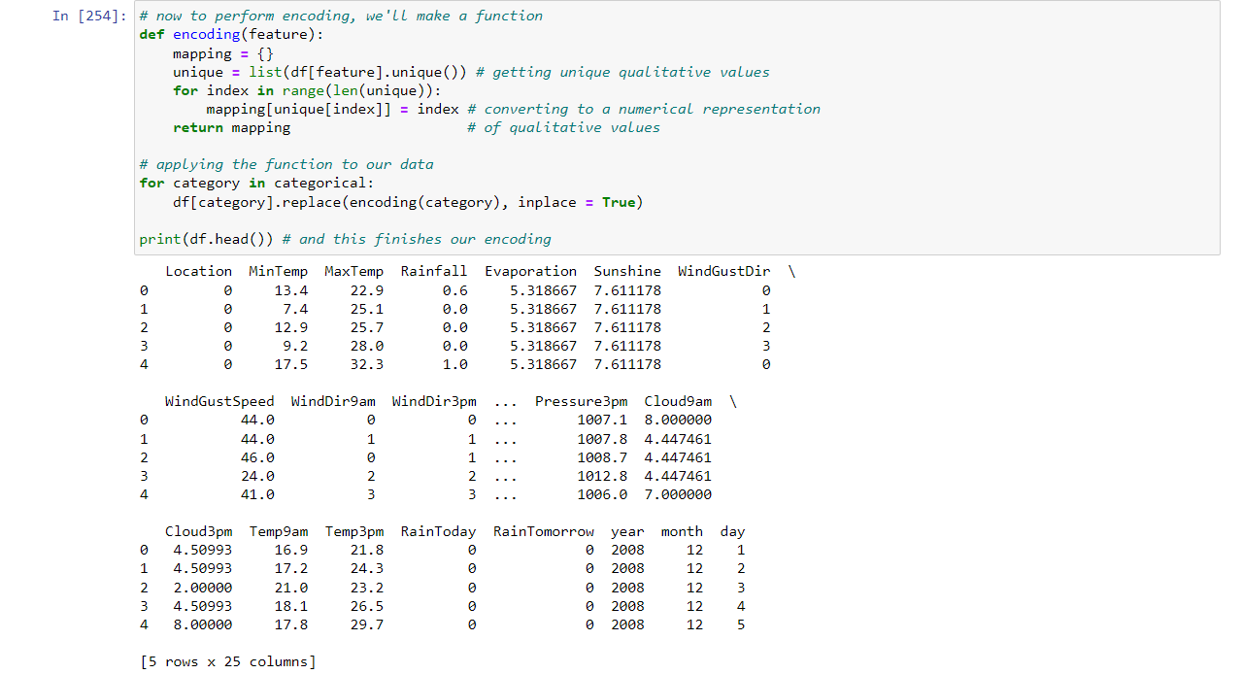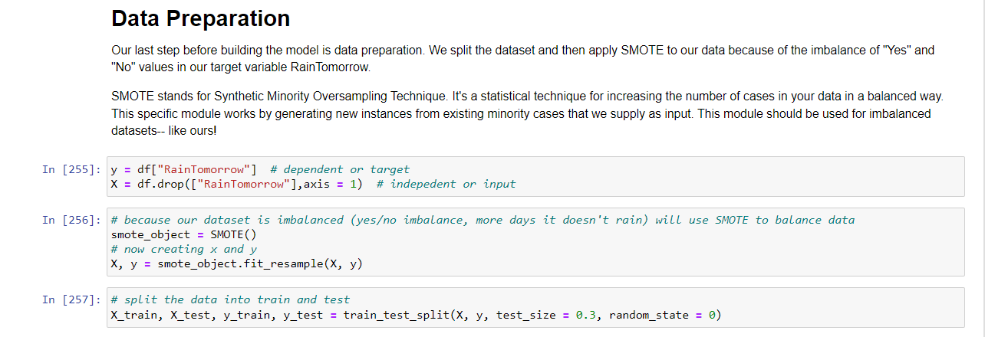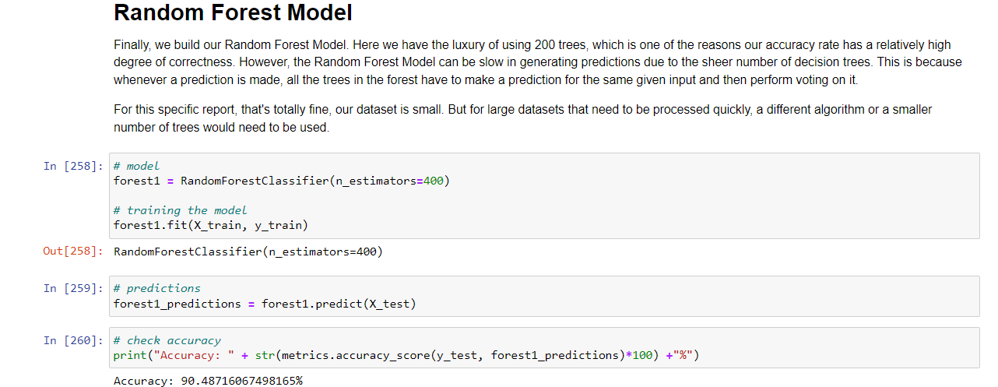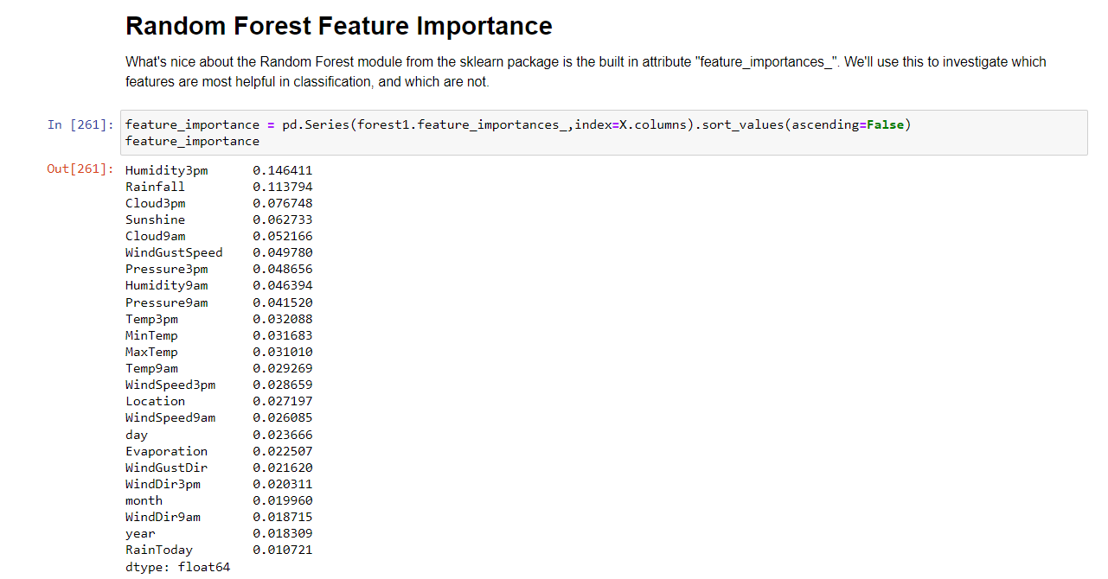

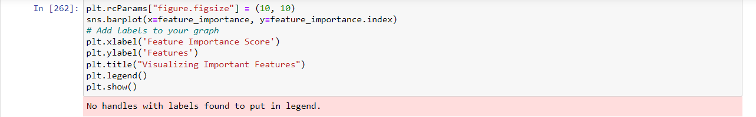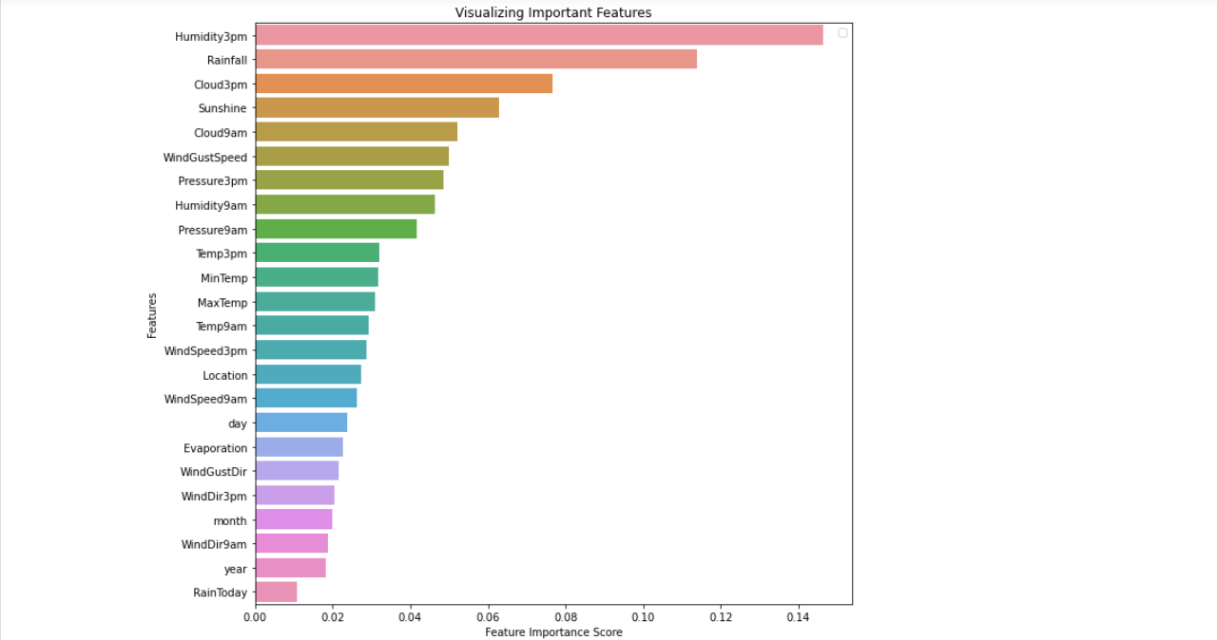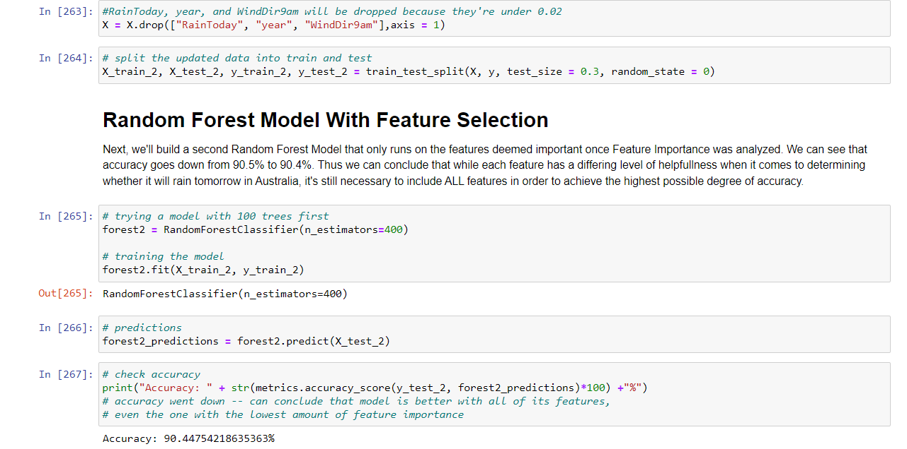

[8]Playing with the parameters….

- By using 200 trees the accuracy = 90.24944974321349%

Random Forest Model With Feature Selection accuracy = 90.24798239178283%

* By using 100 trees the accuracy = 90.24358033749083%

Random Forest Model With Feature Selection accuracy = 90.17754952311078%

-By using 50 trees the accuracy = 90.03081438004402%

Random Forest Model With Feature Selection accuracy = 90.13939838591342%

----------------------------------------------------------------------------

- By using 300 trees the accuracy = 90.40205429200293%

Random Forest Model With Feature Selection accuracy = 90.3947175348496%

* By using 350 trees the accuracy = 90.40205429200293%

Random Forest Model With Feature Selection accuracy = 90.35509904622157%

* By using 400 trees the accuracy = 90.53411592076303%

Random Forest Model With Feature Selection accuracy = 90.43286867204695%

### Name : Ramah hashem madi

### ID no. : 31909303044